Enhanced safety in deep drilling rigs:
New igus energy chain replaces service loops
Modular e-loop energy chain system for secure cable guidance on the top drive

Extreme conditions often prevail in deep drilling rigs in the oil and gas industry: wind and weather, dirt and harsh handling of installations and equipment affect the machine components. igus has now developed the e-loop for the safe guidance of the top drive. The new modular energy chain made of high-performance plastics ensures a defined bend radius of the cables and withstands vibrations and shocks.

Deep drilling rigs with top drive systems are used to extract oil from the earth. For the cable guidance of the systems, manufacturers and operators have so far been using so-called "service loops". However, these often create problems. The cables have no guidance, no defined bend radius, can slip into the service loop and in the worst case, break. In extremely windy conditions, the freely hanging service loop can get caught in the mast or on the sensors as well as the lighting system and be torn off. If any one of these situations occurs and a cable becomes defective, another problem arises: you have to replace the complete dress pack, because the cables are enclosed together within the hose. With the e-loop, igus has now developed a new energy chain that can safely guide cables with large cross sections and heavy weight in hanging applications. The energy supply system is a round, three-dimensional modular system that can move strain-relieved cables with a defined bend radius.

Easy maintenance, assembly and disassembly
When developing the e-loops, the engineers focused on a simple installation. The modular energy chain can be opened from the outside and filled at any time. This allows individual cables to be inserted and replaced quickly in case of maintenance. The chain links can also be replaced at any time. Several secured screw connections are used between the elements of the energy supply, which prevent components from falling down and increasing operational reliability. Since deep drilling rigs need to change locations on a regular basis, the developers are relying on bolted mounting brackets that enable a quick disassembly. In addition to the use on deep drilling rigs, the saltwater-resistant e-loop is also suitable for hanging applications in the offshore industry, for construction machinery, shore power or even wind turbines.

High-performance polymers for secure cable protection
High vibrations, side impacts and bumps do not bother the e-loop. It consists of individual chain links, which have a shock-resistant outer body attachment made of PU foam and cable-friendly inner parts made of the igumid high-performance polymer. The igus material is corrosion-free and chemical-resistant. The new energy supply system from igus is built around a high-tensile plastic rope that absorbs the tensile forces of the cables. The rope is composed of a synthetic plastic fibre and is therefore shatter-proof, weather-resistant, flexible and corrosion-free. The e-loop can absorb weights up to 220 kilonewtons with the rope.

Caption:

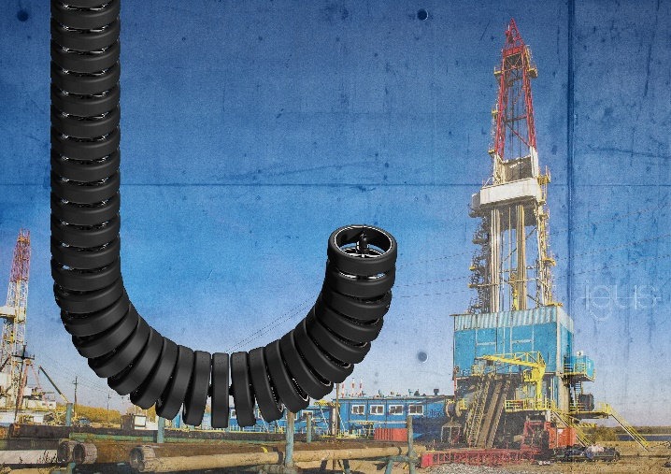
Picture PM3819-1
For secure cable guidance on the top drive: the modular e-loop from igus with a tough, high tensile strength rope, replaces service loops. (Source: igus GmbH)

PRESS CONTACT:  Lena Tan  Operations Director  Asean Region  igus® Singapore Pte Ltd.  84 Genting Lane  #06-03 Axxel Innovation Centre  Singapore 349584  Phone: +65-64 87 14 11  Fax: +65-64 87 15 11  letan@igus.com.sg  www.igus.com.sg | ABOUT IGUS:  igus GmbH is a globally leading manufacturer of energy chain systems and polymer plain bearings. The Cologne-based family business has offices in 35 countries and employs 4,150 people around the world. In 2018, igus generated a turnover of 748 million euros with motion plastics, plastic components for moving applications. igus operates the largest test laboratories and factories in its sector to offer customers quick turnaround times on innovative products and solutions tailored to their needs.

The terms "igus", “Apiro”, "chainflex", "CFRIP", "conprotect", "CTD", "drylin", "dry-tech", "dryspin", "easy chain", "e-chain", "e-chain systems", "e-ketten", "e-kettensysteme", "e-skin", "flizz", “ibow”, “igear”, "iglidur", "igubal", “kineKIT”, "manus", "motion plastics", "pikchain", "plastics for longer life", "readychain", "readycable", “ReBeL”, "speedigus", "triflex", "robolink", and "xiros" are protected by trademark laws in the Federal Republic of Germany and internationally, where applicable.

